Security filter chain:
First request goes through the chain of filters and reaches the controller
Controller is where the application code resides.
If the security is configured we have additional filters related to the security.
Authentication filter.(Login requests which has username and password.that needs to be validated).
Intercept the authentication request grab the username and password and create the authentication object.
Object is handed over to the authentication manager.
It decides what to do with the credentials.
To authenticate we need the authentication provider.(responsible for checking given credentials is correct or not basically to validate the credentials.)
Needs the password encoder and userdetailsservice.
Whenever the user credentials are passed in they will be encoded to decrypt the password the password encoded helps us.
userDetailsService is called by the Authentication provider to load the user details and it loads the username and password.
If the data is stored is stored in the database it will load It from there.
Authentication provider will confirm if the username and password are correct then it will create a complete authentication object.
It will send the object to authentication manager saying this user has been authenticated and it returns back to the authentication filter and then security context is set.
In security context the details of the authentication is stored.
After this process you are allowed to access the controller and then code executes.
DaoAuthenticationProvider. This is the common provider used when you wish to validate the user details.
If you are storing the data in the memory then we can use the InmemoryAuthenticationProvider
And also we have another provider LDAP(Lightweight direct access protocol).
authenticate()-> To authenticate
matches()-> to check If the password gets matches.
loadByUserName()
findByUserName()
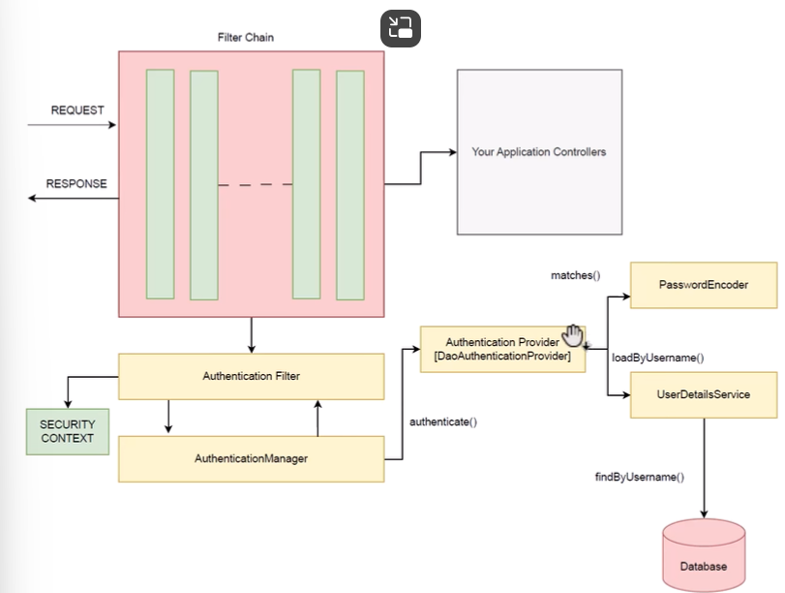
Default authentication is form based authentication.

